**COMP 5120/6120 Database Systems I**

**Homework #4**

1. Suppose that a page can contain at most four data values and that all data values are integers. Using only B+ trees of order 2, give examples of each of the following:
   1. A B+ tree whose height changes from 2 to 3 when the value 25 is inserted. Show your structure before and after the insertion.
   2. A B+ tree in which the deletion of the value 30 leads to a redistribution. Show your structure before and after the deletion.
   3. A B+ tree in which the deletion of the value 35 causes a merging of two nodes but without altering the height of the tree.

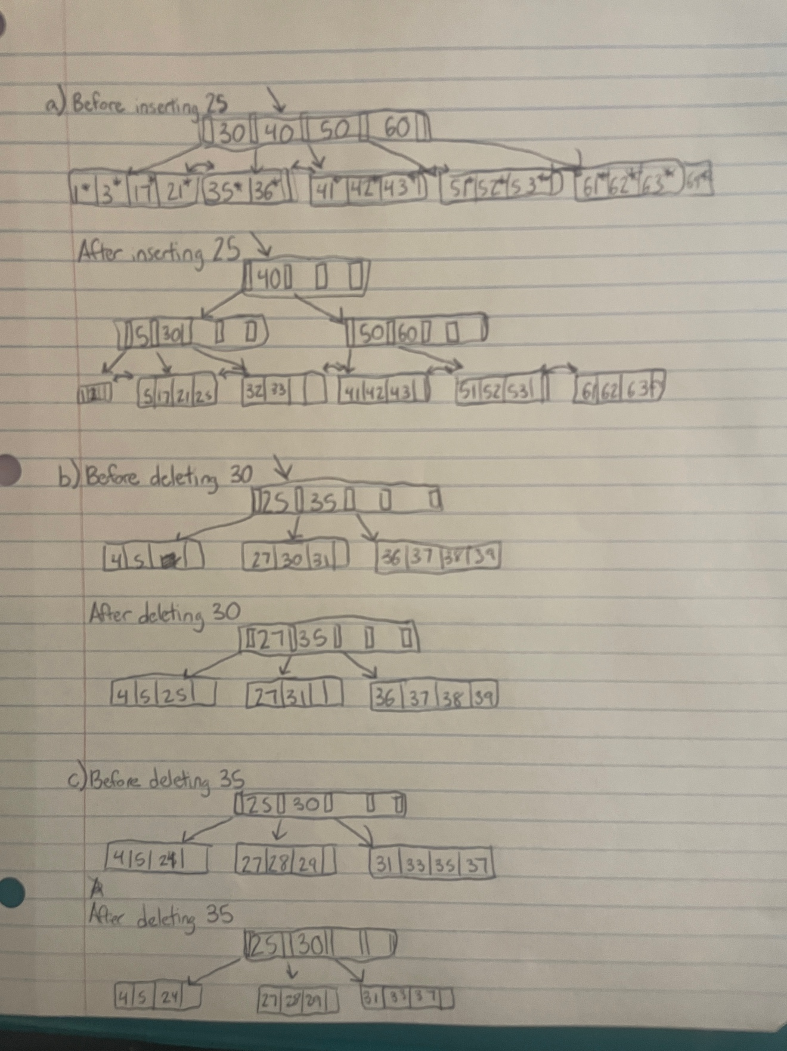

1. Answer the following questions about Linear Hashing:
   1. How does Linear Hashing provide an average-case search cost of only slightly more than one disk I/O, given that overflow buckets are part of its data structure?

Instead of using a directory, Linear Hashing relies on the use of short overflow pages that utilize less space because splits are not concentrated on dense data areas due to the round-robin structure. Bucket pages are also created in order and allocated within the sequence, so a directory is not necessary and therefore won’t take up additional space.

* 1. Does Linear Hashing guarantee at most one disk access to retrieve a record with a given key value?

Linear Hashing does not guarantee at most one disk access to retrieve a record with a given key value because splitting buckets and increasing the number of buckets will require multiple disk access to move from bucket to bucket.